**Instructions for Redistricting with BARD (Better Automated Redistricting)**

This process uses R version 2.12.1 and BARD version 1.18.

**Step 1: Install Files**

R Version2.12.1 can be installed from the following website. <http://cran.r-project.org/>

Select your operating system, and select “base” for Windows. Then follow the installation instructions.

*Previous versions of R software may need to be uninstalled for proper functioning. Uninstalling can be done through the R program area of the start menu or through add/remove programs in the control panel.*

Accept the remaining defaults.

**Step 2: Install additional packages**

In order to use the necessary functionality of BARD, the following packages were needed.

* R2HTML
* gpclib
* rJava
* iPlots

Packages can be installed from within the R graphic user interface through the packages menu.

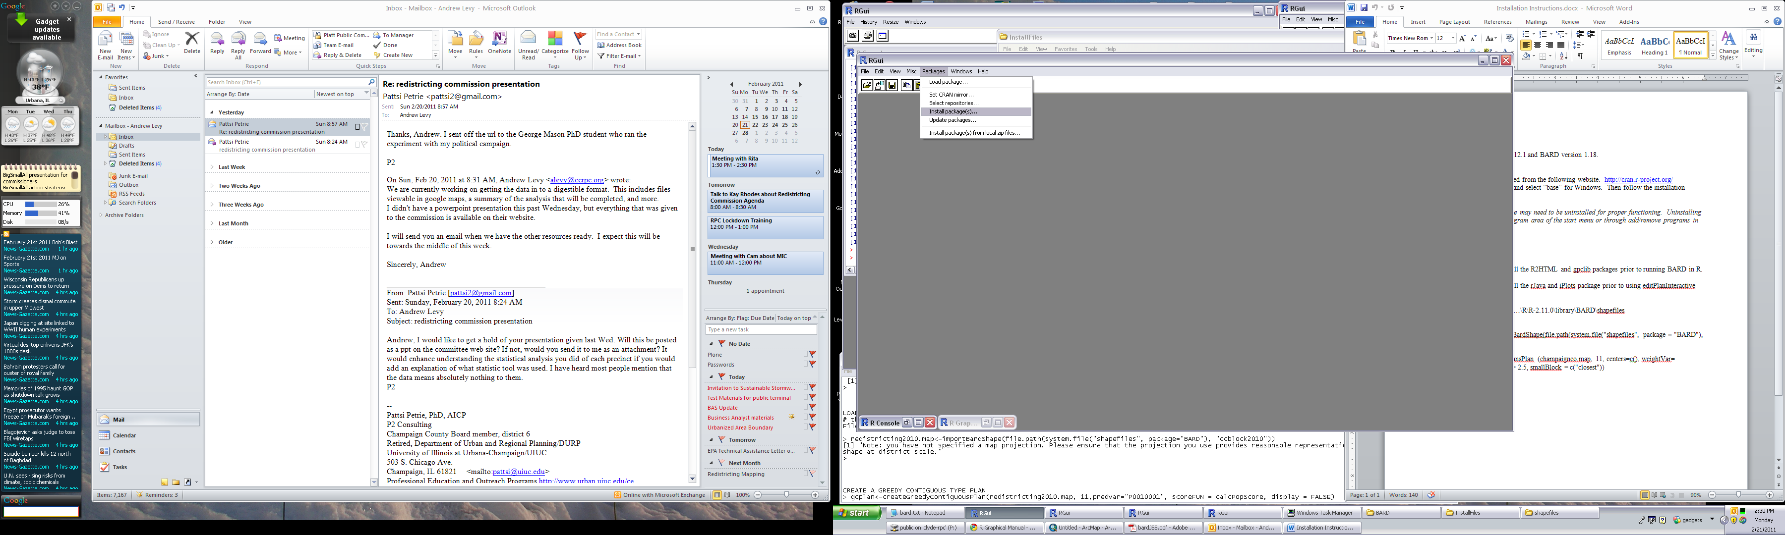

**Step 3: Load BARD into the workspace**

> Library(BARD)

**Step 4: Load spatial data file (shapefile)**

BARD is able to read shapefiles that are accompanied by a .gal file. This is a style contiguity list that can be created through GeoDa (Geodata Analysis Software). The shapefile and .gal files are available for Champaign County Census blocks from the Champaign County Regional Planning Commission. Unformatted files are available from the Census Bureau.

The shapefile and .gal files must be located in the following directory for the following syntax to work.

…\R\R-2.11.0\library\BARD\shapefiles

The following syntax loads the shapefile and .gal file into the workspace.

> rd2010.map <-importBardShape(file.path(system.file("shapefiles", package = "BARD"), "ccblock2010"))

You will receive the following response if successful.

[1] "Note: you have not specified a map projection. Please ensure that the projection you use provides reasonable representation of area, perimeter, and shape at district scale."

**Step 5: Create a redistricting plan**

There are several options for creating redistricting plans. These can be explored with assistance from the R Graphical Manual for BARD. <http://rgm2.lab.nig.ac.jp/RGM2/functions.php?show=all&query=package:BARD&pageID=1>

For Champaign County Redistricting, the RandomPop plan type is being used to generate seed maps which are then refined by BARD. The result is then manually modified by GIS technicians in order to meet the criteria of the Redistricting Commission.

> rpplan<-createRandomPopPlan(rd2010.map, 11, predvar=”P0010001”)

For Champaign County Redistricting, the weighted kmeans plan type is being used to generate seed maps that can be refined by GIS technicians in order to meet the criteria of the Redistricting Commission.

> wkplan<-createWeightedKmeansPlan(rd2010.map, 11, centers=c(),weightVar = "P0010001", trimfactor = 1, smallBlock=c("closest"))

**Step 6: Check the plan**

BARD allows the user to perform calculations and view the plans once they are created.

You can obtain a report of the population of each district through the following syntax.

>calcPopScore(wkplan, predvar=”P0010001”)

You can obtain a report of the compactness measures through the following syntax

>reportPlans(plans=list(“wkplan”=wkplan), dopplot=TRUE)

You can open an image showing the districts that were created through the following syntax.

>plot (kplan)plot

**Step 7: Refine the plan**

There are several tools that can be used to refine the plans. Some of these are computationally intense and may take over 48 hours to complete when using all of the blocks in Champaign County. The following syntax examples have been found to work with varied results.

>improverpplan<-refineGRASPPlan(wkplan, calcContiguityScore, samplesize=50, predvar=”P0010001”, displaycount=NULL, historysize=0, dynamicscoring=FALSE, usecluster=TRUE, tracelevel=1)

>wkplanfix<-fixContiguityPlan(wkplan, calcLWCompactScore)

>gcplanrefine<-redineGreedyPlan(wkplan, score.fun=calcLWCompactScore, displaycount=NULL, historysize=0, dynamicscoring=FALSE, tracelevel=1, checkpointCount=0, resume=FALSE)

**Step 8: Refine the plan interactively**

BARD provides an interface that allows the user to modify districts manually. This component does not work consistently.

>editPlanInteractive(wkplan)

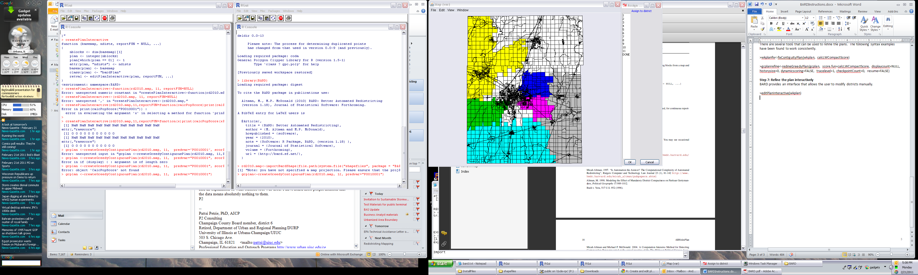

**Step 9: Export the plan to a shapefile**

BARD allows a completed plan to be exported as a shapefile.

>exportBardShape (file.path(“C:/BARD”,”wkplan”), plan=wkplan)

*Other useful links:*

<http://maltman.hmdc.harvard.edu/>

<http://maltman.hmdc.harvard.edu/disab.shtml>